**SENSORY PLAY IDEAS**

**Edible Sensory Play Ideas From the Pantry:**

[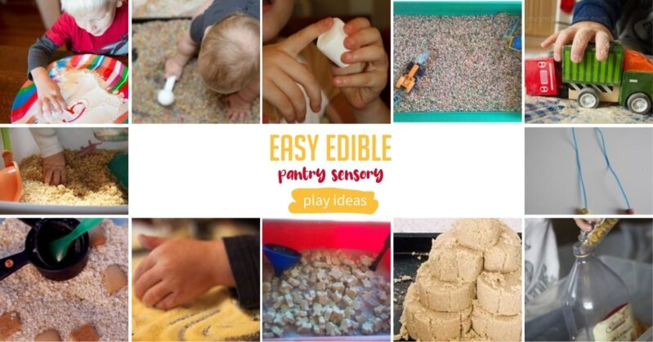](https://handsonaswegrow.com/kids-activities/learning-activities/sensory/)

1. [Colored bread crumbs](http://happilyevermom.com/rainbow-sensory-play-toddlers-babies-kids/) from Happily Ever Mom.
2. [Dry pasta!](https://handsonaswegrow.com/sensory-activity-pasta/) Add scoops and cups for lots of edible sensory play!
3. Make [an indoor sandbox](https://handsonaswegrow.com/edible-indoor-sandbox/) with pantry items, like oatmeal!
4. [Cornmeal is also a great substitute for sand](https://handsonaswegrow.com/corn-meal-sensory-activity-for-toddlers/) when you’re stuck indoors.
5. Messy Motherhood knows [rice crispies are awesome for sensory play](https://messymotherhood.com/rice-cereal-sensory-tray/), they crunch!
6. [Make a necklace with Fruity-Os](http://www.notimeforflashcards.com/2011/06/3-fruity-cheerios-activities-for-kids.html) or just a sensory tub is fun too from No Time for Flash Cards.
7. Making Time for Mommy loves a sweet [hot cocoa mix with marshmallows!](http://www.makingtimeformommy.com/2012/01/29/hot-cocoa-sensory-tub/)
8. [Flour alone is a great sensory activity](https://handsonaswegrow.com/flour-sensory-play-toddlers/) for young kids to play in.
9. My Small Potatoes uses a [bowl of uncooked Cream of Wheat for kids to play in](http://mysmallpotatoes.com/2012/10/04/weekly-kids-co-op-vroom-beep-zoom-imagination-bowl-for-babies/)!
10. Explore all [5 senses with a marshmallow activity](http://www.fantasticfunandlearning.com/exploring-marshmallows-with-the-five-senses.html) from Fantastic Fun and Learning.
11. Build a [sandcastle out of brown sugar](https://handsonaswegrow.com/brown-sugar-sand-castle/) – it’s super moldable!
12. Play on the farm and [follow a maze through dry lentils](http://www.mommyevolution.com/farm-sensory-play/) with an idea from Mommy Evolution!

**EASY EDIBLE PANTRY SENSORY PLAY IDEAS**

[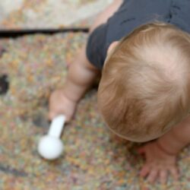](https://happilyevermom.com/rainbow-sensory-play-toddlers-babies-kids/" \t "_blank)

[Rainbow Bread Crumbs](https://happilyevermom.com/rainbow-sensory-play-toddlers-babies-kids/" \t "_blank)

**[HAPPILY EVER MOM](https://happilyevermom.com/rainbow-sensory-play-toddlers-babies-kids/" \t "_blank)**

[](https://handsonaswegrow.com/sensory-activity-pasta/" \t "_blank)

[Dry Pasta Play](https://handsonaswegrow.com/sensory-activity-pasta/" \t "_blank)

**[HANDS ON AS WE GROW](https://handsonaswegrow.com/sensory-activity-pasta/" \t "_blank)**

[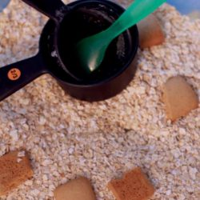](https://handsonaswegrow.com/edible-indoor-sandbox/" \t "_blank)

[DIY Indoor Edible Sandbox](https://handsonaswegrow.com/edible-indoor-sandbox/" \t "_blank)

**[HANDS ON AS WE GROW](https://handsonaswegrow.com/edible-indoor-sandbox/" \t "_blank)**

[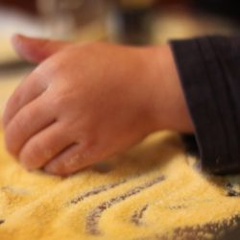](https://handsonaswegrow.com/corn-meal-sensory-activity-for-toddlers/" \t "_blank)

[Edible Cornmeal Sandbox](https://handsonaswegrow.com/corn-meal-sensory-activity-for-toddlers/" \t "_blank)

**[HANDS ON AS WE GROW](https://handsonaswegrow.com/corn-meal-sensory-activity-for-toddlers/" \t "_blank)**

[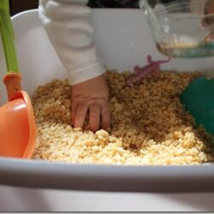](https://messymotherhood.com/rice-cereal-sensory-tray/" \t "_blank)

[Rice Cereal Sensory Bin](https://messymotherhood.com/rice-cereal-sensory-tray/" \t "_blank)

**[MESSY MOTHERHOOD](https://messymotherhood.com/rice-cereal-sensory-tray/" \t "_blank)**

[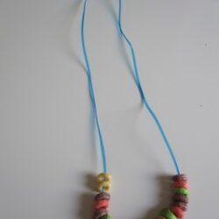](https://www.notimeforflashcards.com/2011/06/3-fruity-cheerios-activities-for-kids.html" \t "_blank)

[Fruity O's Cereal Necklace](https://www.notimeforflashcards.com/2011/06/3-fruity-cheerios-activities-for-kids.html" \t "_blank)

**[NO TIME FOR FLASH CARDS](https://www.notimeforflashcards.com/2011/06/3-fruity-cheerios-activities-for-kids.html" \t "_blank)**

[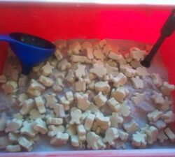](https://www.makingtimeformommy.com/2012/01/29/hot-cocoa-sensory-tub/" \t "_blank)

[Hot Cocoa Sensory Tub + Marshmallows](https://www.makingtimeformommy.com/2012/01/29/hot-cocoa-sensory-tub/" \t "_blank)

**[MAKING TIME FOR MOMMY](https://www.makingtimeformommy.com/2012/01/29/hot-cocoa-sensory-tub/" \t "_blank)**

[](https://handsonaswegrow.com/flour-sensory-play-toddlers/" \t "_blank)

[Flour Writing Activity](https://handsonaswegrow.com/flour-sensory-play-toddlers/" \t "_blank)

**[HANDS ON AS WE GROW](https://handsonaswegrow.com/flour-sensory-play-toddlers/" \t "_blank)**

[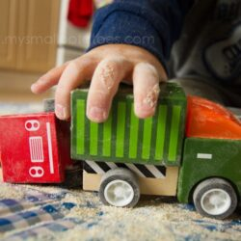](https://mysmallpotatoes.com/2012/10/04/weekly-kids-co-op-vroom-beep-zoom-imagination-bowl-for-babies/" \t "_blank)

[Cream of Wheat Imagination Bowl](https://mysmallpotatoes.com/2012/10/04/weekly-kids-co-op-vroom-beep-zoom-imagination-bowl-for-babies/" \t "_blank)

**[MY SMALL POTATOES](https://mysmallpotatoes.com/2012/10/04/weekly-kids-co-op-vroom-beep-zoom-imagination-bowl-for-babies/" \t "_blank)**

[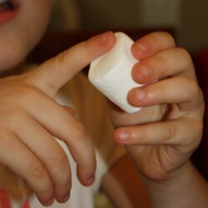](https://www.fantasticfunandlearning.com/exploring-marshmallows-with-the-five-senses.html" \t "_blank)

[5 Senses Marshmallows](https://www.fantasticfunandlearning.com/exploring-marshmallows-with-the-five-senses.html" \t "_blank)

**[FANTASTIC FUN & LEARNING](https://www.fantasticfunandlearning.com/exploring-marshmallows-with-the-five-senses.html" \t "_blank)**

[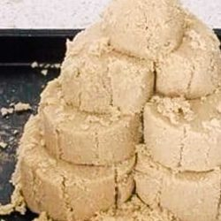](https://handsonaswegrow.com/brown-sugar-sand-castle/" \t "_blank)

[Briwn Sugar Sandcastles](https://handsonaswegrow.com/brown-sugar-sand-castle/" \t "_blank)

**[HANDS ON AS WE GROW](https://handsonaswegrow.com/brown-sugar-sand-castle/" \t "_blank)**

[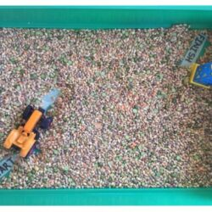](https://mommyevolution.com/farm-sensory-play/" \t "_blank)

[Lentil Sensory Farm Maze Bin](https://mommyevolution.com/farm-sensory-play/" \t "_blank)

You are here: [Home](https://handsonaswegrow.com/) / [Activities](https://handsonaswegrow.com/kids-activities/) / [Learning](https://handsonaswegrow.com/kids-activities/learning-activities/) / [Sensory](https://handsonaswegrow.com/kids-activities/learning-activities/sensory/) / 39 Edible Sensory Play Ideas for Little Kids

# 39 Edible Sensory Play Ideas for Little Kids

[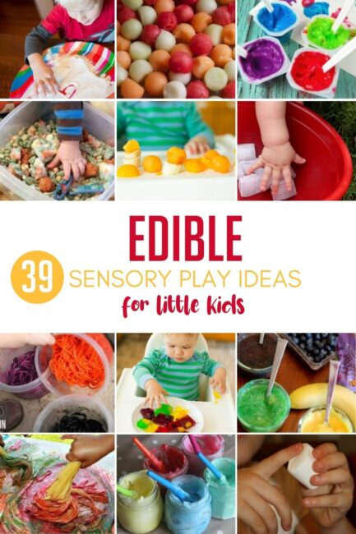](https://handsonaswegrow.com/kids-activities/learning-activities/sensory/)

## 39 Edible Sensory Play Ideas for Little Ones

It’s hard when you have older kids around that want to play with little things, such as the Lego craze we’re on right now in our house.

0 seconds of 15 secondsVolume 20%

03:20

00:31

Louis kind of gets left out of a lot of things simply because he wants to explore everything with his mouth. Everything gets a taste test.

For my own sanity, and maybe yours, I’ve pulled together a list of easy edible sensory play ideas that babies and toddlers will love!

These are all perfect activities for babies, even toddlers, that constantly are mouthing objects.

These sensory play ideas go beyond a sensory tub, I’ve included a few creative sensory activities that are great to branch out and be creative. Everything on the list is edible for those that keep putting things in their mouth.

### Edible Sensory Play Ideas From the Pantry:

[](https://handsonaswegrow.com/kids-activities/learning-activities/sensory/)

#### EASY EDIBLE PANTRY SENSORY PLAY IDEAS

[](https://happilyevermom.com/rainbow-sensory-play-toddlers-babies-kids/" \t "_blank)

##### [Rainbow Bread Crumbs](https://happilyevermom.com/rainbow-sensory-play-toddlers-babies-kids/" \t "_blank)

###### [HAPPILY EVER MOM](https://happilyevermom.com/rainbow-sensory-play-toddlers-babies-kids/" \t "_blank)

[](https://handsonaswegrow.com/sensory-activity-pasta/" \t "_blank)

##### [Dry Pasta Play](https://handsonaswegrow.com/sensory-activity-pasta/" \t "_blank)

###### [HANDS ON AS WE GROW](https://handsonaswegrow.com/sensory-activity-pasta/" \t "_blank)

[](https://handsonaswegrow.com/edible-indoor-sandbox/" \t "_blank)

##### [DIY Indoor Edible Sandbox](https://handsonaswegrow.com/edible-indoor-sandbox/" \t "_blank)

###### [HANDS ON AS WE GROW](https://handsonaswegrow.com/edible-indoor-sandbox/" \t "_blank)

[](https://handsonaswegrow.com/corn-meal-sensory-activity-for-toddlers/" \t "_blank)

##### [Edible Cornmeal Sandbox](https://handsonaswegrow.com/corn-meal-sensory-activity-for-toddlers/" \t "_blank)

###### [HANDS ON AS WE GROW](https://handsonaswegrow.com/corn-meal-sensory-activity-for-toddlers/" \t "_blank)

[](https://messymotherhood.com/rice-cereal-sensory-tray/" \t "_blank)

##### [Rice Cereal Sensory Bin](https://messymotherhood.com/rice-cereal-sensory-tray/" \t "_blank)

###### [MESSY MOTHERHOOD](https://messymotherhood.com/rice-cereal-sensory-tray/" \t "_blank)

[](https://www.notimeforflashcards.com/2011/06/3-fruity-cheerios-activities-for-kids.html" \t "_blank)

##### [Fruity O's Cereal Necklace](https://www.notimeforflashcards.com/2011/06/3-fruity-cheerios-activities-for-kids.html" \t "_blank)

###### [NO TIME FOR FLASH CARDS](https://www.notimeforflashcards.com/2011/06/3-fruity-cheerios-activities-for-kids.html" \t "_blank)

[](https://www.makingtimeformommy.com/2012/01/29/hot-cocoa-sensory-tub/" \t "_blank)

##### [Hot Cocoa Sensory Tub + Marshmallows](https://www.makingtimeformommy.com/2012/01/29/hot-cocoa-sensory-tub/" \t "_blank)

###### [MAKING TIME FOR MOMMY](https://www.makingtimeformommy.com/2012/01/29/hot-cocoa-sensory-tub/" \t "_blank)

[](https://handsonaswegrow.com/flour-sensory-play-toddlers/" \t "_blank)

##### [Flour Writing Activity](https://handsonaswegrow.com/flour-sensory-play-toddlers/" \t "_blank)

###### [HANDS ON AS WE GROW](https://handsonaswegrow.com/flour-sensory-play-toddlers/" \t "_blank)

[](https://mysmallpotatoes.com/2012/10/04/weekly-kids-co-op-vroom-beep-zoom-imagination-bowl-for-babies/" \t "_blank)

##### [Cream of Wheat Imagination Bowl](https://mysmallpotatoes.com/2012/10/04/weekly-kids-co-op-vroom-beep-zoom-imagination-bowl-for-babies/" \t "_blank)

###### [MY SMALL POTATOES](https://mysmallpotatoes.com/2012/10/04/weekly-kids-co-op-vroom-beep-zoom-imagination-bowl-for-babies/" \t "_blank)

[](https://www.fantasticfunandlearning.com/exploring-marshmallows-with-the-five-senses.html" \t "_blank)

##### [5 Senses Marshmallows](https://www.fantasticfunandlearning.com/exploring-marshmallows-with-the-five-senses.html" \t "_blank)

###### [FANTASTIC FUN & LEARNING](https://www.fantasticfunandlearning.com/exploring-marshmallows-with-the-five-senses.html" \t "_blank)

[](https://handsonaswegrow.com/brown-sugar-sand-castle/" \t "_blank)

##### [Briwn Sugar Sandcastles](https://handsonaswegrow.com/brown-sugar-sand-castle/" \t "_blank)

###### [HANDS ON AS WE GROW](https://handsonaswegrow.com/brown-sugar-sand-castle/" \t "_blank)

[](https://mommyevolution.com/farm-sensory-play/" \t "_blank)

##### [Lentil Sensory Farm Maze Bin](https://mommyevolution.com/farm-sensory-play/" \t "_blank)

###### [MOMMY EVOLUTION](https://mommyevolution.com/farm-sensory-play/" \t "_blank)

### More Edible Sensory Play Ideas From the Kitchen:

[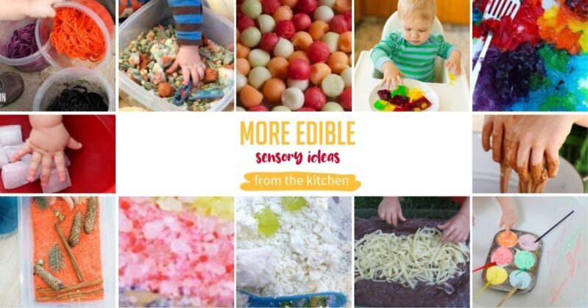](https://handsonaswegrow.com/kids-activities/learning-activities/sensory/)

1. Merri Cherry loves this [simple rainbow jello sensory play activity](http://www.mericherry.com/2013/09/30/rainbow-jello-sensory-play-for-babies-and-toddlers/)!
2. Learn, Play, Imagine [made fizzy oobleck with cocoa](http://www.learnplayimagine.com/2014/02/erupting-chocolate-oobleck.html) for some chocolate-y sensory ideas!
3. Busy Toddler whips up [edible cool whip tub paint](https://busytoddler.com/2015/10/cool-whip-painting/) for messy-clean sensory play fun.
4. Play in pudding “dirt” with pasta “worms” for [gross-out sensory fun](https://www.themeasuredmom.com/edible-sensory-play-ooey-gooey-worms/) from The Measured Mom.
5. [Make coconut dough](http://www.creativeplayhouse.mumsinjersey.co.uk/2013/07/crumbly-coconut-dough.html), with an idea from Creative Playhouse.
6. Fresh fruit, [balls of melons make a refreshing sensory tub](https://playathomemom3.blogspot.com/2013/03/melon-balls-edible-sensory-bin.html) for babies to taste test, like Play at Home Mom.
7. Explore [fruit in fruit jigglers!](http://www.modernparentsmessykids.com/2014/03/learning-explore-food-play.html) Modern Parents, Messy Kids added cookie cutters for more fun!
8. Dig [frozen veggies](https://handsonaswegrow.com/edible-sensory-bin-babies/) out of the freezer! A chilly sensory bin!
9. Colored [cooked spaghetti](https://handsonaswegrow.com/sensory-activity-spaghetti-potion/)! Slimy Fun!
10. Ice! So simple, yet [ice is so fun for kids to play with](https://handsonaswegrow.com/baby-play-ice-sensory/), it gets slippery and hard to hold on to!
11. Add a little seasonal scent to just plain rice for a fun [scented sensory discovery bin](https://handsonaswegrow.com/pumpkin-scented-rice-sensory-bin/)!
12. Try adding a colorful twist to salt and [DIY a rainbow](https://handsonaswegrow.com/diy-rainbow-salt-sensory-play/) at home!

[SEE MORE](https://eb2.3lift.com/pass?tl_clickthrough=true&redir=https%3A%2F%2Fpr.ybp.yahoo.com%2Fcj%2Fcd%2F-pSQG3XDJ3tvg2YvMmS-TXMNdSLF2bQqjC_adByUT99fFj9l2NiPNVVjhTFx7bc7NBzbeHtxeyXdxJubc4rWczfPUQnfFB8xNuChIcH6ZcorHDN7doCAlJNUvFLlkT-F-tmoEXvM-XqwZR-8J__ff8VuZY9qjwZmhqJ7fP8ZEoQOYmD8XPUlwavmYQPNaruZfEvgDDaH_O6_gMB0QyfrcSunseKEzspzKNAGsEyo97Ruzqw982dYtWETSxaKZ8SnmVDUYgmZcP_pG9r8bN3jEg%2Frurl%2Fhttps%3A%2F%2Fad.doubleclick.net%2Fddm%2Ftrackclk%2FN6344.3020245OATH.COM%2FB26497406.316903504%3Bdc_trk_aid%3D509237072%3Bdc_trk_cid%3D159448306%3Bdc_lat%3D%3Bdc_rdid%3D%3Btag_for_child_directed_treatment%3D%3Btfua%3D%3Bltd%3D&ss=39&bc=1.163&pr=0.660676&brid=558437&bmid=2662&biid=2662&aid=30583626148180419210&tid=9242763&bcud=1163&sid=79441&ts=1642100128&cb=19288)

https://ib.3lift.com/static/buttons/edaa/OBA_TRANS.png



#### MORE EDIBLE SENSORY IDEAS FROM THE KITCHEN

[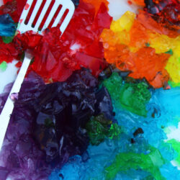](http://mericherry.com/2013/09/30/rainbow-jello-sensory-play-for-babies-and-toddlers/" \t "_blank)

##### [Rainbow Jello Sensory Play](http://mericherry.com/2013/09/30/rainbow-jello-sensory-play-for-babies-and-toddlers/" \t "_blank)

###### [MERRI CHERRY](http://mericherry.com/2013/09/30/rainbow-jello-sensory-play-for-babies-and-toddlers/" \t "_blank)

[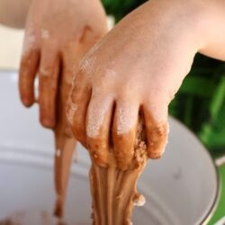](http://www.learnplayimagine.com/2014/02/erupting-chocolate-oobleck.html" \t "_blank)

##### [Erupting Chocolate Oobleck](http://www.learnplayimagine.com/2014/02/erupting-chocolate-oobleck.html" \t "_blank)

###### [LEARN, PLAY, IMAGINE](http://www.learnplayimagine.com/2014/02/erupting-chocolate-oobleck.html" \t "_blank)

[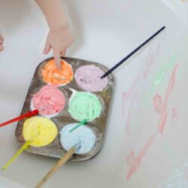](https://busytoddler.com/2015/10/cool-whip-painting/" \t "_blank)

##### [Edible Cool Whip Tub Paint](https://busytoddler.com/2015/10/cool-whip-painting/" \t "_blank)

###### [BUSY TODDLER](https://busytoddler.com/2015/10/cool-whip-painting/" \t "_blank)

[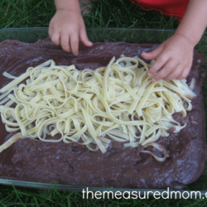](https://www.themeasuredmom.com/edible-sensory-play-ooey-gooey-worms/" \t "_blank)

##### [Pasta + Pudding = Muddy Sensory Fun](https://www.themeasuredmom.com/edible-sensory-play-ooey-gooey-worms/" \t "_blank)

###### [THE MEASURED MOM](https://www.themeasuredmom.com/edible-sensory-play-ooey-gooey-worms/" \t "_blank)

[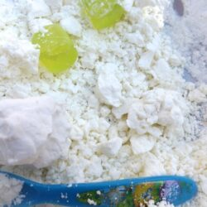](https://www.creativeplayhouse.mumsinjersey.co.uk/2013/07/crumbly-coconut-dough.html" \t "_blank)

##### [Coconut Crumble Dough](https://www.creativeplayhouse.mumsinjersey.co.uk/2013/07/crumbly-coconut-dough.html" \t "_blank)

###### [CREATIVE PLAY HOUSE](https://www.creativeplayhouse.mumsinjersey.co.uk/2013/07/crumbly-coconut-dough.html" \t "_blank)

[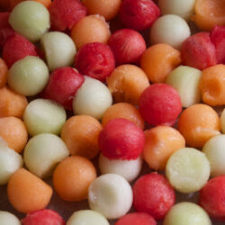](http://www.playathomemomllc.com/2013/03/melon-balls-an-edible-sensory-bin/" \t "_blank)

##### [Edible Melon Ball Scooping](http://www.playathomemomllc.com/2013/03/melon-balls-an-edible-sensory-bin/" \t "_blank)

###### [PLAY AT HOME MOM LLC](http://www.playathomemomllc.com/2013/03/melon-balls-an-edible-sensory-bin/" \t "_blank)

[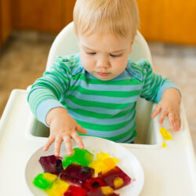](https://modernparentsmessykids.com/learning-explore-food-play/" \t "_blank)

##### [Fruity Jello Jigglers](https://modernparentsmessykids.com/learning-explore-food-play/" \t "_blank)

###### [MODERN PARENTS MESSY KIDS](https://modernparentsmessykids.com/learning-explore-food-play/" \t "_blank)

[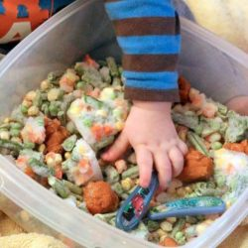](https://handsonaswegrow.com/edible-sensory-bin-babies/" \t "_blank)

##### [Frozen Veggie Excavation](https://handsonaswegrow.com/edible-sensory-bin-babies/" \t "_blank)

###### [HANDS ON AS WE GROW](https://handsonaswegrow.com/edible-sensory-bin-babies/" \t "_blank)

[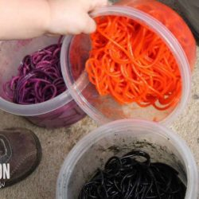](https://handsonaswegrow.com/sensory-activity-spaghetti-potion/" \t "_blank)

##### [Colorful Cooked Spaghetti](https://handsonaswegrow.com/sensory-activity-spaghetti-potion/" \t "_blank)

###### [HANDS ON AS WE GROW](https://handsonaswegrow.com/sensory-activity-spaghetti-potion/" \t "_blank)

[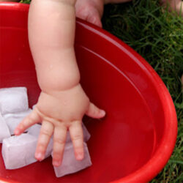](https://handsonaswegrow.com/baby-play-ice-sensory/" \t "_blank)

##### [Just Plain Ice](https://handsonaswegrow.com/baby-play-ice-sensory/" \t "_blank)

###### [HANDS ON AS WE GROW](https://handsonaswegrow.com/baby-play-ice-sensory/" \t "_blank)

[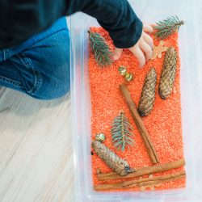](https://handsonaswegrow.com/pumpkin-scented-rice-sensory-bin/" \t "_blank)

##### [Seasonal Scented Rice Discovery Bin](https://handsonaswegrow.com/pumpkin-scented-rice-sensory-bin/" \t "_blank)

###### [HANDS ON AS WE GROW](https://handsonaswegrow.com/pumpkin-scented-rice-sensory-bin/" \t "_blank)

##### [DIY Rainbow Salt](https://handsonaswegrow.com/diy-rainbow-salt-sensory-play/" \t "_blank)

###### [HANDS ON AS WE GROW](https://handsonaswegrow.com/diy-rainbow-salt-sensory-play/" \t "_blank)

[SEE MORE](https://eb2.3lift.com/pass?tl_clickthrough=true&redir=https%3A%2F%2Fpr.ybp.yahoo.com%2Fcj%2Fcd%2F7Hlc1X07fvSzq-m9N2lsQSg-RBhBR6TvrjZnoE0_j-Z_Di6oJO82mG2UGX_SXr9BQcq5YbW5I0827clOqIoupXaHy04wuI61oteKEmYN2lwqh3RVEwI9Um5UKWP4jq5FlwPK-2fZg_YzrPcrTuaqWrdDrDWbMAPVg76nVRgc0mmpYLHgjOea-4CUncaAeoITnIEzQFjRNsar1Qgq3EuvmuE9oQyntQKG-iKZAT4unSKzv6lfGa6f0frwK3KxX7jPQliYDwIcN7buoEf45vsozpRnv0hfpZh8%2Frurl%2Fhttps%3A%2F%2Fad.doubleclick.net%2Fddm%2Ftrackclk%2FN6344.3020245OATH.COM%2FB26434439.321651616%3Bdc_trk_aid%3D513724406%3Bdc_trk_cid%3D162435279%3Bdc_lat%3D%3Bdc_rdid%3D%3Btag_for_child_directed_treatment%3D%3Btfua%3D%3Bltd%3D&ss=39&bc=2.794&pr=0.775446&brid=558437&bmid=2662&biid=2662&aid=30281136479854822310&did=29699&tid=10572284&bcud=2794&sid=79441&ts=1642100491&cb=79197)